

**PeaceHealth- Peace Island Medical Center – 2/24/16**

**Semi-Annual Report to San Juan County Public Hospital District #1 Board of Commissioners for 7/1/15 to 12/31/15.**



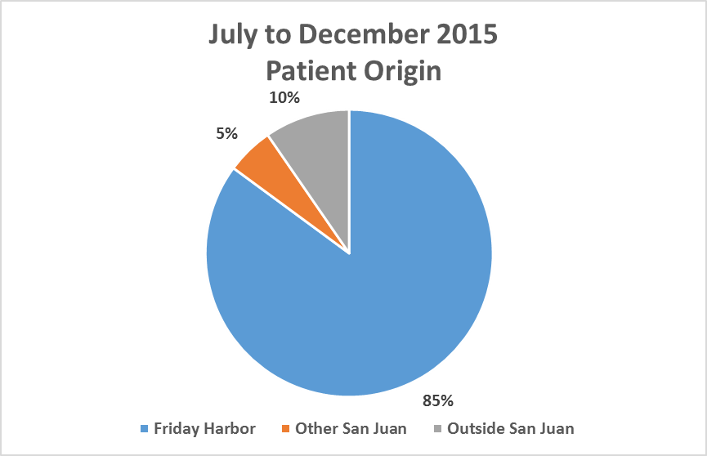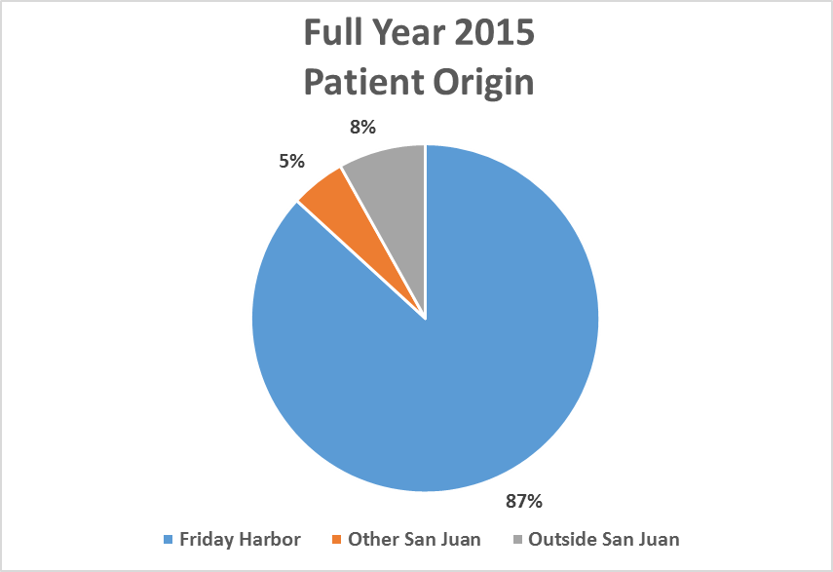

1. **Health care Services Provided**

* Emergency Care is provided to District residents and visitors 24/7, 365 days a year in the PIMC Emergency Department (ED).
* Walk-in urgent care is provided on Saturdays in the ED from 10am to 4pm. During this reporting period, 51 patients sought walk-in urgent care on Saturdays for a total of 115 patients in 2015.
* PIMC advanced to a Level IV Trauma designation effective July 1st, 2015. This designation demonstrates the capability to provide advanced trauma life support to patients in need prior to transferring them to a higher level trauma center, where they will arrive evaluated, stabilized, and diagnosed by our caregivers. In addition to providing these services, a Level IV Trauma Center must have a trauma nurse and physician on site upon patient arrival and 24-hour laboratory coverage. Kudos to Sheryl Murphy, RN, and Michael Sullivan, MD, ED Director, for the diligent work they put into the application this designation.
* PIMC provides comprehensive emergency care with discharge and outpatient follow up, as well as island-appropriate admissions to our inpatient unit. Both allow patients to stay in their community for hospital stays. These inpatient admissions are supported by 24/7 Hospitalist care.
* Behavioral health and/or assault crisis care is available in collaboration with community law enforcement. PIMC ED staff provides safe, compassionate, quality care to evaluate, hold and transfer these patients when it is necessary to send them out of the community for extended care.
* There are now two adult SANE (Sexual Assault Nurse Examiner) registered nurses on staff at PIMC. These RNs will work in collaboration with the community in the creation of a Sexual Assault Response Team.
  1. **Primary Care with PeaceHealth Medical Group**:
* Family Medicine and Internal Medicine clinic appointments are scheduled Monday through Friday from 8:30am to 5:00pm. Each PIMC primary care provider provides same day access appointment slots for urgent care on a daily basis. This allows for daily accommodation of 12 to 24 patients for same day urgent care Monday through Friday during clinic business hours.
* Available services include comprehensive Family Medicine and Internal Medicine clinic services, Coumadin monitoring, diabetic education, integrated behavioral health case management and telemedicine consults.
* PIMC primary care providers work in collaboration with the San Juan County Health Department providing CDC reporting, Women’s Infants and Child Care programs, Newborn Care and in the promotion of increasing immunization rates by encouraging “Community Immunity.”
* Our primary care providers also work in collaboration with Life Care of the San Juan Islands providing weekly direct patient care to Life Care residents while they are staying in the skilled nursing facility (SNF).
* Patients may also take advantage of My PeaceHealth—PeaceHealth’s online patient medical record access program. Our clinic providers make it easy to connect with their patients using My PeaceHealth email messaging, appointment scheduling and printing of lab results and correspondence after each appointment. In person My PeaceHealth assistance is available monthly by volunteers trained to assist patients with sign up and navigation of the program.
  1. **Behavioral Health Consultant Services in Primary Care:**
* In September 2015, an integrated behavioral health consultant service program began in primary care provided via a doctoral internship with Arizona State University. Gary Waters, MSW, Ed.S, began his internship program aimed at improving access to behavioral health care services by aligning primary care medicine and behavioral health care to include immediate consultation, assessment, intervention, and case management, upon referral by the primary care physician. Data collection and reporting is part of the program to demonstrate how a patient’s health can be improved and satisfactory outcomes increased through integrated and co-located treatment available via one system. A report prepared by Mr. Waters from September 2015 through December 2015 includes general data relating to patient contacts and a summary of integrated care and behavioral health initiatives planned in 2016. A service card describing the telepsychiatry project is also included and will be available for distribution to patients and San Juan County primary care providers.

 

* 1. **Visiting Specialty Medical Care** continues at PIMC for patient convenience and care continuity. A visiting specialist calendar is offered monthly by both private, community-based practitioners and PeaceHealth Medical Group employed providers:

The monthly visiting specialists include:

* OB/GYN – Robert Prins, MD, of Fidalgo Medicine in Anacortes, and Melinda Milligan, Certified Nurse Midwife from Orcas Island, who are in their 10th year of providing routine prenatal care services to San Juan County patients. Both of these OB/GYN providers are in private practice and offer labor and delivery services at Island Hospital in Anacortes. In July, Nadine Burrington Foist, MD, of Anacortes added a third day each month for obstetrics and gynecology specialty services.
* Visiting cardiologists from PeaceHealth Medical Group are in the clinic two days a month, on the first and fourth Friday and will expand their care by offering a telecardiology follow-up program for post-surgical patients.
* Oncology is provided by PeaceHealth Medical Group physicians, Jennie Crews, MD and Andrew Kominsky, MD, including follow-up Cancer Survivorship services provided by PeaceHealth teleoncology.
* David Olson, MD, is a private practitioner from Bellingham in his 8th year of providing monthly, on-island ear nose and throat (ENT) care.
* Telepsychiatry is offered by Mark Newman, MD, of UW Medicine Psychiatry Department and Amber Kostial, MD, of PeaceHealth’s Behavioral Health Department. Both psychiatrists offer consultations on Tuesdays via referrals from the patient’s primary care provider.
* Pediatric consultation is offered monthly by PeaceHealth Medical Group physician, Steven Ban, MD.
  1. **Outpatient Surgical Services** continue to be scheduled at PIMC. Endoscopy, colonoscopy, orthopedic and other outpatient general surgery procedures are scheduled monthly. PIMC has invested in state-of-the-art capital equipment to advance outpatient surgical services.
* Orthopedic surgical consults and outpatient procedures are provided by PeaceHealth Medical Group physician, Jeffery Krusniak, DO.
* Gastroenterology consults and GI outpatient procedures are offered monthly by private, community-based providers and PeaceHealth Medical Group visiting specialists.
* A range of outpatient general surgical procedures are offered at PIMC by private practice general surgeon, Michael Pietro, MD, of Bellingham. Dr. Pietro provides outpatient surgeries such as hernia repair, vasectomy, hemorrhoid repair, port placement and complicated lesion removal.
  1. **Telemedicine Specialty Consultations**: Thanks to a HRSA federal grant, PIMC has interactive video conferencing equipment that is used to provide specialty consultations and individualized treatment plans for hospitalist care, psychiatry and oncology in collaboration with community providers in San Juan County. Specialty tele-consult services in cardiology, dermatology, social services, and crisis behavioral health care are available to PeaceHealth Peace Island Medical Center physicians for patients in the emergency department, inpatient and primary care clinic. The NW Washington, SE Alaska Telehealth Network grant also provided San Juan Island EMS $20,000 in grant funds to purchase polycom equipment for placement on Orcas and Shaw islands to facilitate ongoing EMT training and staff development programs.
  2. **Diagnostic Imaging Services** volumes continue to grow.
* State-of-the-art imaging equipment includes a 64-slice Computed Tomography (CT) with the upgrade to the NEMA XR-29 standard known as ‘MITA Smart Dose’ in September 2015. The XR-29 standard upgrade includes features of the CT that enable management of radiation dose delivery while also providing high quality medical images. This upgrade means that PIMC offers our community the safest and lowest radiation dose possible.
* Digital Diagnostic Radiography, mobile fluoroscopy for trauma and surgery, is available 24/7. General Ultrasound with limited vascular and endocardiography is provided four days per week. Mobile full body and neuro MRI service is offered twice a month.
* Bone Densitometry, providing advanced body composition and atypical fracture assessment, is available daily as needed.
* EKG/Treadmill is provided daily as needed.
* Digital Mammography is available every Tuesday.
  1. **Diagnostic Medical Lab Service** offers a test menu of 73 tests available STAT and performed on site. The lab has a staff of five who provided extended hours in 2015 to better support Saturday and Sunday inpatient and emergency department needs. The lab staff also provides 24/7 call support outside of the official lab hours. The lab added PCR technology for improved specificity and sensitivity in flu testing. Test numbers have continued to increase another 10 % over the last six-month period, breaking the test volume record once again.
  2. **Pharmacy Services** aresupported by a full-time pharmacist and full-time pharmacy technician, both local residents. The PIMC pharmacy supports physicians’ practices to grant medication requests that improve patient care. The PIMC pharmacy collaborates with the San Juan County Health Department to support the needs of the community by making sure needed medications (such as rabies vaccines and post exposure prophylaxis medication) are available to all residents of San Juan County. In 2015 there was an increase in the number of patients requiring pharmacy services in the Cancer Care and Specialty Infusion centers; as a result, the PIMC pharmacy increased the medications that they carry to accommodate physicians’ orders for these patients. PIMC pharmacy also sends patients home with chemotherapy medication pumps and coordinates care for patients so that they may receive necessary treatment close to home.

1. **Number and Type of Clinical Providers**
   1. **Primary Care Practitioners in Clinic –** There are five permanent members of the PeaceHealth Medical Group team of primary care providers working at PIMC: Rachel Bishop, MD, board-certified Family Practice physician and Family Practice Medical Director; Susan Mahoney, MD, board-certified Family Medicine, and Chief of Staff; Cheryl Kubisty, MD, board-certified Internal Medicine, and Hospitalist Medical Director; and William Gunderson, MD, board-certified Internal Medicine physician, Hospitalist and integrated behavioral health internship preceptor. Mallory Brown, ARNP, Family Practice, joined the clinic staff full-time in August and is scheduled in the clinic full time, five days a week. PIMC’s Family Practice clinical providers offer same day and routine pediatric patient care five days a week.
   2. **Emergency Department Practitioners**: All eight physicians who treat patients in PIMC’s Emergency Department are board certified in Emergency Medicine. Emergency Medicine physicians include: Michael Sullivan, MD, a permanent resident of San Juan Island, is Medical Director of PIMC Emergency Medicine and a member of the PIMC Community Health Board. Jason Heiner, MD, UW Medicine Residency Director and Medical Program Director for San Juan Island EMS ground ambulance service. Sean Stone, MD, serves as the Medical Director for San Juan Island air ambulance services. Kevin Bowman, MD, Warren Appleton, MD, Mark Zarzycki, MD, Wade Henrichs, MD, and Jena Lopez, MD travel from off-island to San Juan Island to help staff PIMC’s Emergency Department.

Recruitment continues for an additional board-certified Emergency Medicine physician with the goal to recruit a physician who will live on San Juan Island. Hosting a regular Emergency Department residency rotation may prove a critical strategy in attracting new physicians to move to a rural location like San Juan Island to live and work full time.

* 1. **Cancer Care and Specialty Services:**
* Our Medical Oncology and Hematology Clinic and Infusion Center continue to be led by board-certified Medical Oncologists, Jennie Crews, MD, and Andrew Kominsky, MD.
* Physician appointments were up over this same period last year including teleoncology and telesurvivorship care follow-up appointments.
* The center completed another support group series from October to December called “Our Common Bond.” This special support group has become popular in the community with the next series expected to start in the spring of 2016.
* With the support of the PeaceHealth Peace Island volunteers, our center provided Chemo Care kits to all our new chemotherapy patients. These special kits are filled with comfort items and are received with delight by our patients.
* A therapeutic massage provider was added to the cancer care program and has served patients for the past six months.
  1. **Clinical Education**: Rural Emergency Medicine rotations in partnership with UW Medicine were completed over the summer. Four Emergency Medicine residents working under the supervision of our attending physicians in the ED reported their expectations for this rotation were met. After the rotation, three of the four residents reported they were more likely to practice in a rural setting after their experience at PIMC. Outside of the ED experience, the residents participated in EMS, sheriff’s boat and Island Air ride-along transports. They gave lectures to EMS personnel, participated in the local community health fair and provided more than 15 free childhood sports physicals. Feedback from these residents included comments such as: “I learned how to manage patients with limited resources and consultants,” and “Participating in the interaction between a critical access hospital and EMS system was a valuable component of this elective rotation.” There are more resident rotations at PIMC planned for Emergency Medicine and Family Medicine in spring 2016.
  2. A new affiliation agreement between Whatcom Community College and PeaceHealth Peace Island Medical Center was signed which would designate PIMC as a clinical training site for certified nursing assistant students living in San Juan County. The first students should begin training in the spring of 2016.

1. **Nature and Results of Quality Initiatives**
   1. Patient Safety remains the focus at PIMC. The Quality Management System Plan for calendar year 2015 describes the quality management system established by PIMC to achieve its quality and safety objectives and goals. The plan outlines the methodologies and practices by which quality and performance are measured, monitored, analyzed and continually improved to advance health outcomes and reduce risks for patients. The plan also summarizes the calendar year 2015 quality focus areas with associated targets and strategies for achieving those targets.

A summary of quality activity occurring at PIMC and reported to the Joint Quality and Patient Experience Committee includes:

**Risk Management review:** Managing the grievance process and responses within the appropriate time frames. There were no serious safety events noted in this reporting period. The focus of this committee work is on improvement rather than on blame.

**Quality Dashboard:** The committee hears updates on the key metrics that are continuously monitored:

* Pain assessments.
* Medication reconciliation.
* Bar code medication administration.
* Patient experience data.

**Quality and Infection Prevention plans:** The draft quality and infection prevention plans for calendar year 2016 will be approved by the PIMC Community Health Board in March and a copy will be provided to the District at the next semi-annual report in July.

**Regulatory updates:** All regulatory work plans are in place and on track.

***PIMC Excellence Recognized by the State of Washington Office of Rural Health* – press release:**

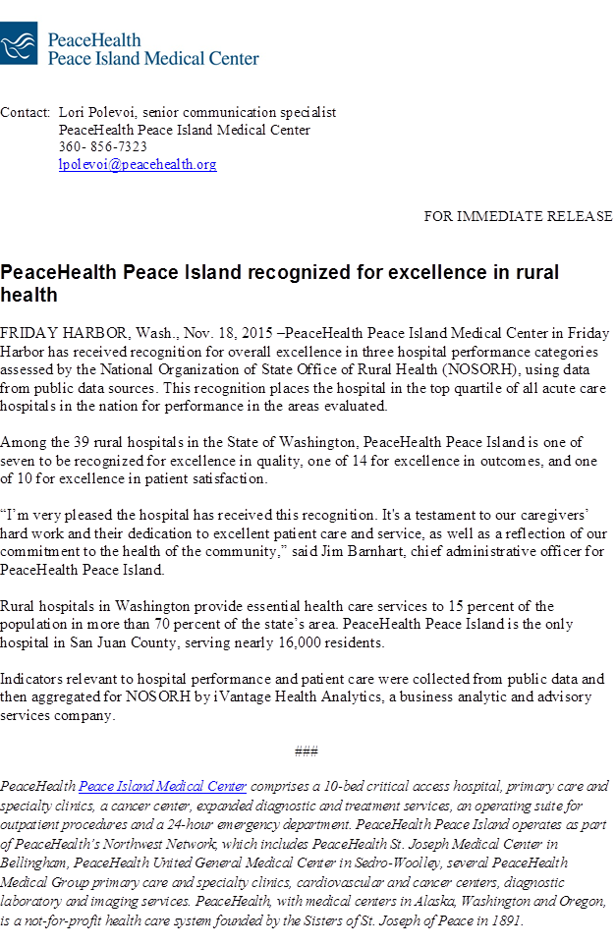

**Community Health Needs Assessment** (CHNA): This assessment was completed in December 2014 and approved by the PIMC Community Health Board in January 2015. A copy was provided to the San Juan County Public Hospital District Board in January.

Along with PeaceHealth Peace Island Medical Center, San Juan County Public Hospital District #1 is a core member of the San Juan County Community Health Consortium as are the San Juan County Health Department, the San Juan Island Family Resource Center and many other community partners. In August 2015, the Consortium subgroups convened on a monthly basis to define goals, objectives and begin to identify essential collaborative partnerships. Included is a PowerPoint update of the work of the San Juan Community Health Consortium:



1. **Patient Experience Indicators**

Melissa Morrison, Patient Experience Manager for PeaceHealth, works with PIMC leadership and provides coaching for providers to improve patient experience. She is also near completion of facilitating the Language of Caring curriculum for all caregivers.  Other patient experience work includes hourly purposeful registered nurse care rounds and nurse leader rounding on inpatient and in the Emergency Department.   These system-wide initiatives are designed to improve the patient care experience scores we are focusing on in FY2016. A summary PowerPoint of the PIMC patient experience indicators from July 2015 to December 2015 is included:



1. **Financial Viability of the Operation**: Per the First Amendment to the Subsidy Agreement, dated Sept. 15, 2010, attached is the semi-annual financial report ending December 2015.



**Conclusions of the six-month report:**

On healthcare services covered by the subsidy (Charitable Services, Emergency Department and Physician Services) the estimated six-month loss, without the subsidy, is $2,419,769. With an estimated tax subsidy of $741,500, the loss is reduced to $1,678,269.

Total PeaceHealth services provided for the same period, resulted in a margin of $518,000, or, 5.8% with the subsidy, and, a loss of ($223,995), or, -2.5% without the subsidy.

**“1.1.23 Use of District Payments:** PeaceHealth shall utilize all payments from the District exclusively for the provision of the following healthcare services within the District: charitable healthcare services, emergency department services and the provision of physician services. “Charitable healthcare services” shall mean those services described in paragraph 1.1.20, above, including charity care, bad debt and the difference between allowed Medicare and Medicaid rates and the charges for all services rendered to patients covered by Medicare and Medicaid. “Emergency Department services” shall mean those services described in paragraph 1.1.18(2), above, as attributed to the emergency department on the general ledger for Peace Island Hospital. “Physician services” shall mean those primary care physician services described in paragraph 1.1.18 (1), above, as attributed to physician services in the general ledger for Peace Island Hospital and for the PeaceHealth Medical Group- San Juan Island.”