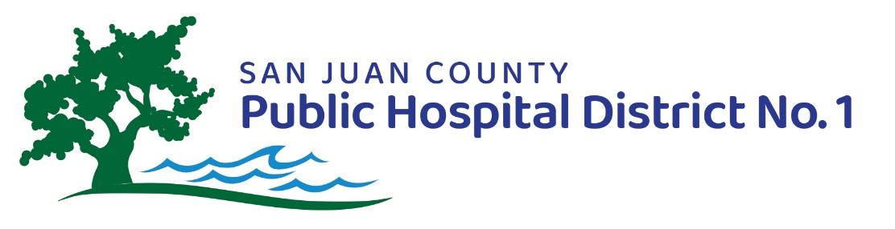

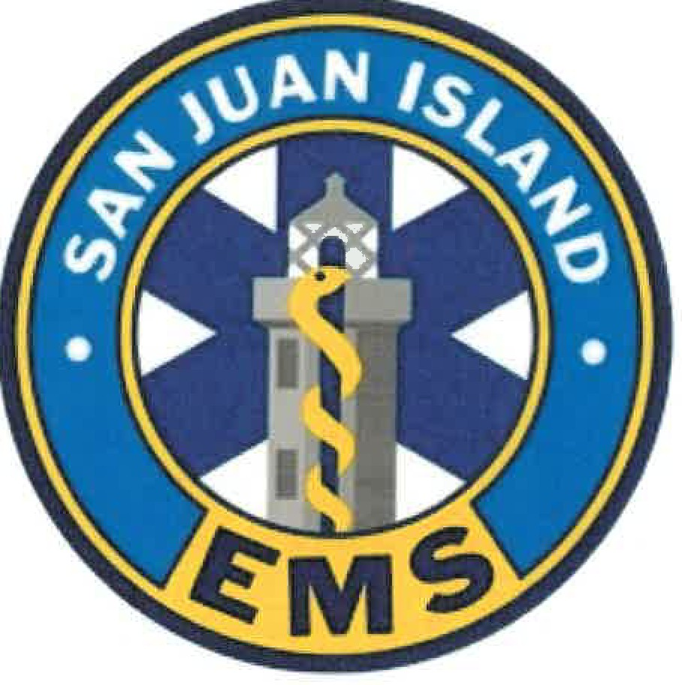

MONTHLY REPORT

Presented January 26, 2022
(for December 2021)

SAN JUAN COUNTY PUBLIC HOSPITAL DISTRICT NO. 1
AND
SAN JUAN ISLAND EMERGENCY MEDICAL SERVICES

FINANCIAL REPORTS

Supporting data can be found in the financial reports sent separately. A year-end report is available separately, this is intended for December 2021 only.

SJCPHD #1 FINANCIALS (Fund 6521)

2021 BUDGET Consolidated Overall COMPARISONS – 100% into 2021
- REVENUE = $41,587; cumulative for 2021 = $1,592,957; or 99% of budget projections (after taking out beginning cash)
- EXPENSES = 67,398; Cumulative for 2021 = $1,561,873 or 99% of budget projections (after taking out budgeted ending cash)
- CASH = $723,824

ANALYSIS:

The District landed financial right where expected, with revenue and expenditures at 99% of budgeted values, and has sufficient cash on hand for the next payment to PeaceHealth in February 2022.

SAN JUAN ISLAND EMS FINANCIALS (Fund 6511 and 6512)

2021 BUDGET Consolidated Overall COMPARISONS – 100% into 2021
- REVENUE = $ 95,762; Cumulative 2021 = $ 2,297,253; or 95% of budget projections (after taking out beginning cash)
- EXPENSES = $ 298,290; Cumulative 2021 = $ 3,168,110; or 100% of budget projections (after taking out budgeted ending cash)
- CASH, RESERVES, INVESTMENTS = $ 836,011
  - CASH = $ 705,367
  - RESERVES (FUND 6512) = $ 130,644
  - INVESTMENTS = $ 0.00

ANALYSIS:

A few comments on these numbers:
- Ambulance and GEMT money came in from summer and fall billing
- The full anticipated ACH Funding came in a little short, but did come in.
- Revenue constriction continues to be a challenge due to decreased GEMT and somewhat lower than expected ambulance service fees

OPERATIONS REPORTS

SJCPHD#1 – OPS REPORT

In December we selected a bank to sponsor our bond to purchase the Village at the Harbor. The bond amount, including closing costs, is estimated at $5,000,000. We were grateful to be able to accept the proposal from Savi Bank. We would like to thank the five banks that submitted proposals – all but one were very good proposals. The Savi Bank proposal offers an excellent rate and a generous draw-down term.

We worked very hard to prepare for the implementation of the Village at the Harbor in December. This involved talking to IT, banks, the county payroll and warrants staff, working on contracts and job descriptions, preparing and working through all due diligence steps, and more.

During the cold weather we did have a pipe break in the suite above our hospital district administrative offices, which made quite a mess. However, it does not appear to have caused lasting damage. We were very lucky that it came down through the fan in the ceiling and into a wide-open space with no furniture.

Our Audit began late November and has taken a moderate amount of time working with the auditor and getting them the documents that they need.

Our HRSA Care Coordination grant is going through some transition as we began looking into a partnership with Lyn at the suggestion of Anne Presson.

The budget that the Board approved in November has been submitted to the county, and this is the last month that we will receive tax money at the rate or $0.34 per $1,000 in assessed value. In January, we will begin assessing $0.70 per $1,000 in assessed value in order to fund the expansion of long-term care services. That money should begin to show up in March and April 2022.

SJIEMS – STATISTICAL REPORT (OPS PART 1)

Department Stats – December 2021
- Monthly: 80 runs for December 2021
  - There were 59 calls from December 1, 2020 to December 31, 2020 = 35% increase over December 2020
  - Not all calls result in a response, they may be stood down for one reason or another; this is the total number of times the agency was paged
- Year of 2021: 1086 calls January 1, 2021 through December 31, 2021
  - There were 1,032 calls from January 1, 2020 to December 31, 2020 = 3% annual increase over 2020
- Average number of responders per call = 2.9
- Destinations: PIMC = 41, Island Air = 5, Airlift NW = 11, LifeFlight = 1, Navy= 0, Coast Guard = 0
- Monthly Average Chute Time – EMS (time of page until resource rolling) = 2:06
- Average Scene Time – EMS = 25:11
- Monthly Average Response Times continue to be within suburban benchmarks. Benchmark times are per North Region EMS & Trauma Care Council standards which comply with State RCWs and WACs
  - Overall - Average response time 10:01 with 89% of calls under 20:00 (benchmark for suburban area) and 87% under 10:00 (urban benchmark)
  - In Town – 46 calls (58%) – Average response time 6:07 with 85% under 8:00
  - Mid-Island – 18 calls (22%) - Average response time 12:16 with 100% of calls under 20:00 and 89% under 10:00
  - North end – 9 calls (11%) Average response time 23:03 with 55% of calls under 20:00 and 0% under 10:00
  - South end – 7 calls (9%) - Average response time 13:13 with 100% of calls under 20:00 and 20% under 10:00
  - Outer Island – 0 calls (0%) inside of district
    - 0 call out of district
    - Note that these are raw times, not adjusted for staging or extended wait times for ALNW arrival, or simultaneous calls

SAN JUAN ISLAND EMS – OPS REPORT (OPS PART 2)

IAFF LOCAL #3219

New hire Michelle Savoie completed her EMT onboarding and began filling shifts on her own as a solo EMT. This brings our complement of full-time EMTs up to five. No other news.

Operations

Operations continue under the Covid-19 response model initiated in late March 2020. Our new ambulance was very much appreciated during the late December snowfall.

Staff and Agency Training

In December the agency does elective operational training. We did not do run reviews in December due to the holiday.

Community

Classroom training for American Heart Association continues, with precautions in place.

We issued 55 cards in December
- Heartsaver First aid CPR/AED, in person class on location - 16
- Heartsaver First aid CPR/AED, skills only - 2
- BLS Provider, skills only – 37

Additionally, our car seat program continues. Infant car seats: Gifted – 0, Loaner – 0, Installation only – 0

Convertible: Gifted – 0, Loaned – 0, Installation only – 0

Boosters: 0

Bicycle helmets: 1

Community Paramedicine

The main goals of the community paramedicine program and service have not changed. They remain: to improve the quality of life and health for our citizens while reducing the cost of healthcare. This meets the hospital district’s goal of “aging in place”. Through Community Paramedicine, we can identify short- and long-term patient outcomes that are appropriate for measuring the success of a variety of interventions.

In December 2021, there were 90 enrolled in total, of whom 37 patients are actively engaged, 26 under observation, and 4 referred but not yet enrolled, 3 refused, and 1 closed.

EMS – Fire Integration

The Board decided in December 2021 not to pursue the merger of EMS and Fire any further. The Fire District’s EMS levy in the November 2021 election failed to reach the required supermajority (60%) to be established as a new levy.

The Board voted to send a ballot measure to the public for a vote in the February 2022 election cycle. This ballot measure is the EMS levy renewal, effective following the expiration of the current levy on December 31, 2022. If passed, the new levy will take effect January 1, 2023 at $0.45 per $1,000 in assessed value.

The District released a Frequently Asked Questions (FAQ), six-year budget plan, budget plan narrative, and more, in an effort to be transparent with the public.

Civil Investigative Demand (CID)

In December 2021 there was no update regarding the CID.

Covid-19 Situation

We continue to operate under our Emergency Declaration. The county reported the following benchmarks for the number of active cases for San Juan Island in December.
- December 3, 2021 : 4 new cases on San Juan Island
- December 10, 2021 : 4 new cases on San Juan Island
- December 17, 2021 : 1 new cases on San Juan Island
- December 24, 2021 : 2 new cases on San Juan Island
- December 31, 2021 : 7 new cases on San Juan Island (note: 47 new cases on Orcas, an all-time high to this point)

Our “Stop the Spread” Policies and protocols continue to be adapted to meet the situation, but we are complying with CDC guidelines in permitting removal of masks in small groups of fully vaccinated people in the station. Personal protective equipment (PPE) supplies remain adequate. Nearly every member of our agency is fully vaccinated.

It should be noted that subsequent to this report, in January of 2022, Covid cases have increased many-fold, due to Omicron. The current situation at the time of writing (mid-January) is that of substantial covid-19 infection across the county.

Respectfully submitted,

Nathan Butler
Superintendent, San Juan County Public Hospital District No. 1
EMS Administrator, San Juan Island Emergency Medical Services

